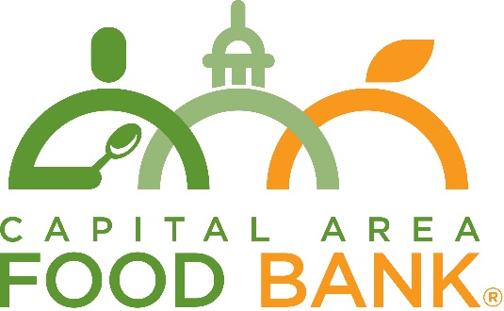

Media Advisory

For more information, please contact:
Hilary Salmon
Capital Area Food Bank
202-644-9864
hsalmon@capitalareafoodbank.org

FOR IMMEDIATE RELEASE

STARBUCKS AND FEEDING AMERICA® PARTNER WITH CAPITAL AREA FOOD BANK TO LAUNCH STARBUCKS FOODSHARE PROGRAM
FoodShare program expected to provide over 730,000 meals worth of nourishing, ready-to-eat food each year to people in need

April 13, 2021 – Today, Starbucks, Feeding America® and Capital Area Food Bank announced the launch of the Starbucks FoodShare program in the Washington metro region.

As part of the FoodShare program, Starbucks donates nourishing, ready-to-eat meals each day to Feeding America member food banks from its company-operated stores in the U.S. With donations from 337 local Starbucks locations, the program is estimated to provide over 883,000 pounds of food, or the equivalent of 736,000 meals* annually to those in need throughout the area.

“The impacts of the pandemic on our region have been profound, and more of our neighbors than ever – close to 600,000 people, a third of whom are children – may not know where their next meal will come from,” said Radha Muthiah, President and CEO of the Capital Area Food Bank. “Our partnerships are critical to our ability to respond, and we’re proud to partner with Starbucks to ensure that people who face hunger have access to nutritious meals. The FoodShare program is a strong example of what we can accomplish when we work together.”

“Starbucks is committed to doing our part to alleviate hunger in the U.S., especially now as food banks are navigating the growing hunger crisis due to the pandemic,” says Jane Maly, social impact director at Starbucks. “Now, more than ever, it is critical to ensure we are rescuing all available food and donating it to communities in need.”

FoodShare donations will be delivered to the food bank seven days a week, year-round. Food items include Protein Boxes, breakfast sandwiches, paninis, yogurts and high-quality baked goods.

The donated food will play an important role in helping the food bank provide meals to children, families, and seniors through several of its partners located in Prince George’s county, MD. Prince George’s county has one of the highest rates of food insecurity in the greater Washington area.

*According to the USDA, 1 meal is the equivalent of 1.2 pounds of food.

###

ABOUT CAPITAL AREA FOOD BANK
The Capital Area Food Bank works to address hunger today and create brighter futures tomorrow for the nearly 600,000 people across the region experiencing food insecurity. As the anchor in the area’s hunger relief infrastructure, they provided over 62 million meals to people in need over the past year by supplying food to hundreds of nonprofit organizations, including Martha’s Table, SOME – So Others Might Eat, DC Central Kitchen, Food for Others, Manna, and others. They also work in partnership with organizations across the region to address hunger’s root causes by pairing food with other critical services.

ABOUT STARBUCKS
Since 1971, Starbucks Coffee Company has been committed to ethically sourcing and roasting high-quality arabica coffee. Today, with stores around the globe, the company is the premier roaster and retailer of specialty coffee in the world. Through our unwavering commitment to excellence and our guiding principles, we bring the unique Starbucks Experience to life for every customer through every cup. To share in the experience, please visit us in our stores or online at https://stories.starbucks.com/

