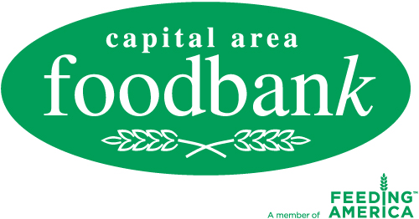

Media Advisory
For more information, please contact:
Shamia K. Holloway
Capital Area Food Bank
202-526-5344 ext. 230
202-526-1253 fax
sholloway@capitalareafoodbank.org

www.CapitalAreaFoodBank.org

FOR IMMEDIATE RELEASE

Local Public Relations Agencies Challenge Raises Food and Funds for Capital Area Food Bank

Annual Food Drive to Help Feed Families in Need During Holiday Season
What: Area public relations agencies Edelman, Hill & Knowlton, Ketchum,
Fleishman-Hillard and Ogilvy hosted a food drive challenge to benefit the Capital Area Food Bank. Firms challenge each other to donate the most goods per capita, assigning point values to CAFB’s most wanted list of goods. This is the fourth year of the food drive competition.
Who: - Edelman
- Hill & Knowlton
- Ketchum
- Fleishman-Hillard
- Ogilvy

When: Thursday, December 8, 2011
8:30 – 9 AM

Where: Capital Area Food Bank
645 Taylor Street, NE
Washington, DC 20017

Why: More than 600,000 Washington, DC metro area residents, including 200,000 children, are facing persistent hunger and malnutrition, a 25 percent increase in recent years. In Northern Virginia, over 217,000 people and 1 in 6 children are at risk of hunger. The CAFB, including its Northern Virginia Branch, provides individuals and families with nutrition education and outreach programs designed to address the root cause of hunger.

The Capital Area Food Bank, founded in 1980, delivers 30 million pounds of food – half of which is fresh produce – annually to 480,000 individuals in the Washington, DC metro area. The CAFB takes a comprehensive approach to addressing hunger by increasing access to nutritious food, initiating change through skill-building and advocacy, and creating sustainability with outreach and training for those at risk of hunger. The CAFB is the metro area's largest public, nonprofit food and nutrition education resource.

###

