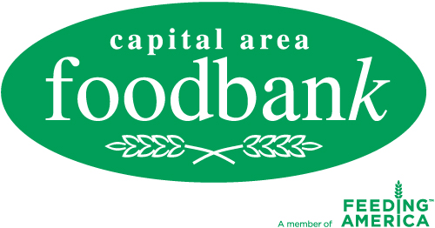

News Release
For more information, please contact:
Page Crosland
Capital Area Food Bank
202-526-5344 ext. 316
202-529-1253 fax
croslandp@capitalareafoodbank.org

FOR IMMEDIATE RELEASE
President Obama and Family Volunteer at Capital Area Food Bank
for Special Thanksgiving Distribution to Region’s Hungry

Washington, DC, Nov. 23—When a group of low-income seniors and children from throughout the region visited the Capital Area Food Bank the day before Thanksgiving, they were stunned and delighted to find President and Mrs. Obama and members of their extended family packing and distributing bags filled with special holiday food.
Lynn Brantley, President and CEO of the CAFB, said, “This is truly a special day for all of us. Thank you President and Mrs. Obama, Sasha and Malia, and your family and friends for volunteering today and helping us feed those in need. You have made this a memorable Thanksgiving by helping send a message on behalf of those struggling with hunger in these difficult times.”

Today’s volunteers packed food bags for three of the CAFB’s programs. Low-income seniors participating in the food bank’s Senior Brown Bag program are provided with monthly bags of food and educational information on nutrition at 34 area locations. Children who receive free or reduced breakfast and lunch during the week at school are also given nutritious bags of food from Weekend Bag program distribution sites. The Kids Cafe program serves 2,000 children in 60 locations in recreation, religious and community centers and schools throughout the region. The bags are packed by volunteers -- 14,000 annually -- at the food bank and delivered by food bank trucks to the partner agencies, or sites designed to serve children.

Today’s food recipients regularly participate in five of over 700 CAFB partner agencies in the Washington metro area: Brookland Manor Boys and Girls Club, Washington, DC; SEED, Inc., Riverdale, MD; Avondale/Manor Apartments, Hyattsville, MD; Queenstown, Mount Rainier, MD; and Shabach Emergency Resource & Empowerment Center, Landover, Md.

Brantley continued, “We are facing a hunger crisis in the region and throughout the nation. One in every two children in the nation’s capital is at risk of hunger – that’s 200,000 children in the region we serve – the District, Northern Virginia and Prince George’s and Montgomery counties in Maryland.”

A recent survey of CAFB partner agencies revealed that they are experiencing a 10 to 75 percent increase in those they serve. Calls to the food bank’s Hunger Lifeline have increased 173 percent for July – September of this year from the same period in 2010.

The Capital Area Food Bank, a member of Feeding America, was founded on January 15, Martin Luther King’s birthday, in 1980 and takes a comprehensive approach to addressing hunger by increasing access to nutritious food, initiating change through skill-building and advocacy, and creating sustainability with outreach and training for those at risk of hunger. It distributes annually 30 million pounds of food, half of which is fresh produce. The CAFB is the Washington metro area’s largest public, nonprofit food and nutrition education resource.

