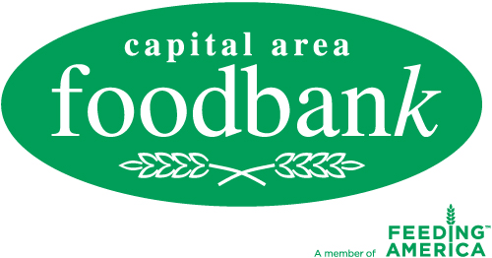

Media Advisory
For more information, please contact:
Page Dahl Crosland
Capital Area Food Bank
202-526-5344 ext. 316
202-526-1253 fax
croslandp@capitalareafoodbank.org

www.CapitalAreaFoodBank.org

FOR IMMEDIATE RELEASE

CAPITAL AREA FOOD BANK HOSTS
3RD ANNUAL FEDS FEED FAMILIES FOOD DRIVE KICK OFF

What: The Capital Area Food Bank hosts the 3rd annual Feds Feed Families food drive kick-off at the food bank warehouse. During this national food drive occurring in June, July and August, federal employees deliver non-perishable produce to designated boxes within their agencies. The drive began two years ago when President Obama signed the Serve America Act and created “United We Serve,” calling on all Americans to contribute to the nation’s economic recovery by serving in their communities. In response to this call, the U.S. Office of Personnel Management (OPM) and the Chief Human Capital Office (CHCO) Council formed a partnership through the Feds Feed Families food drive campaign. Last year, the CAFB received 310,294 lbs. of food.

Who: John Berry, U.S. Office of Personnel Management (OPM)
U.S. Rep. Eleanor Holmes Norton (D-DC)
Kathleen Merrigan, Deputy Secretary of Agriculture
Pat Tamburrino, Deputy Assistant Secretary of Defense for Civilian
Personnel Policy
Members of the Chief Human Capital Officers (CHCO) Council
Lynn Brantley, CAFB President & CEO
Mitch Green, CAFB Chef-In-Residence

When: Thursday, May 26, 2011
11 AM – 12 PM

Where: Capital Area Food Bank
645 Taylor Street, NE
Washington, DC 20017

Why: More than 600,000 metro area residents, including 200,000 children, are facing persistent hunger and malnutrition, a 25 percent increase since 2006. The CAFB provides individuals and families with nutrition education and outreach programs designed to address the root cause of hunger.

The Capital Area Food Bank, founded in 1980, takes a comprehensive approach to addressing hunger by increasing access to nutritious food, initiating change through skill-building and advocacy, and creating sustainability with outreach and training for those at risk of hunger. The CAFB is the metro area's largest public, nonprofit food and nutrition education resource. For more information about hunger and nutrition issues, log on to CapitalAreaFoodBank.org.

###

