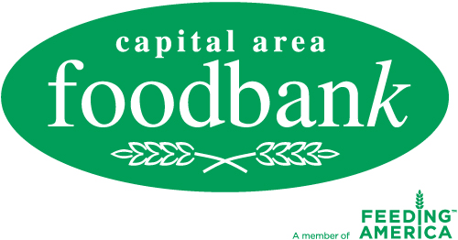

Media Alert
For more information, please contact:
Page Dahl Crosland
Capital Area Food Bank
202-526-5344 ext. 316
202-526-1253 fax
croslandp@capitalareafoodbank.org

www.CapitalAreaFoodBank.org

FOR IMMEDIATE RELEASE

CAPITAL AREA FOOD BANK
SEEKS PUBLIC SUPPORT
AS REGION FACES HUNGER CRISIS

$ 1,000,000 Campaign to Fund Fresh Produce Will Be Announced

What: The Capital Area Food Bank is facing a 30 percent increase in transportation and food costs and is seeking public support for additional funding to reduce the costs that may have to be passed on to its 700 plus partner agencies. At issue is a potential shared maintenance fee of 10 cents a pound for fresh produce distributed to CAFB partner agencies, if the necessary funding is not found.

Who: --Lynn Brantley, CAFB President & CEO
--George Jones, CAFB Board Member and Executive Director, Bread for the City, Inc
--Hannah Hawkins, CAFB Board Member and Founder and Director of Children of Mine, Inc.

When: 1 pm, Tuesday, June 28

Where: Children of Mine, Inc.
2263 Mount View Place, SE
Washington, DC 20020

Why: More than 600,000 metro area residents, including 200,000 children, are facing persistent hunger, a 25 percent increase since 2006. The CAFB provides individuals and families with nutrition education and outreach programs designed to address the root cause of hunger.

Visuals: Fresh produce garden where children are taught to grow fruits and vegetables.

The Capital Area Food Bank, founded in 1980, takes a comprehensive approach to addressing hunger by increasing access to nutritious food, initiating change through skill-building and advocacy, and creating sustainability with outreach and training for those at risk of hunger. The CAFB is the metro area's largest public, nonprofit food and nutrition education resource. For more information about hunger and nutrition issues, log on to CapitalAreaFoodBank.org.

